1.

Right now, the DataStandardizer class is parsing the data sets inefficiently. With the current format, trying to parse new data sets from different companies requires changing a lot of code in the class. Instead of doing this, the data could be parsed by using the company name as a key for the specific algorithm for reformatting that organization’s data which would be the value.

2.

This would involve making a new DataStandardizer for each company which would be harder to maintain. Overriding the parse() method is not the best idea because there would be a lot of duplicate code with regards to reading the strings in each file. The only thing that changes for each company is the code nested in the while loop so instead of having a bunch of unnecessary code, only a handful of lines need to be written.

3.

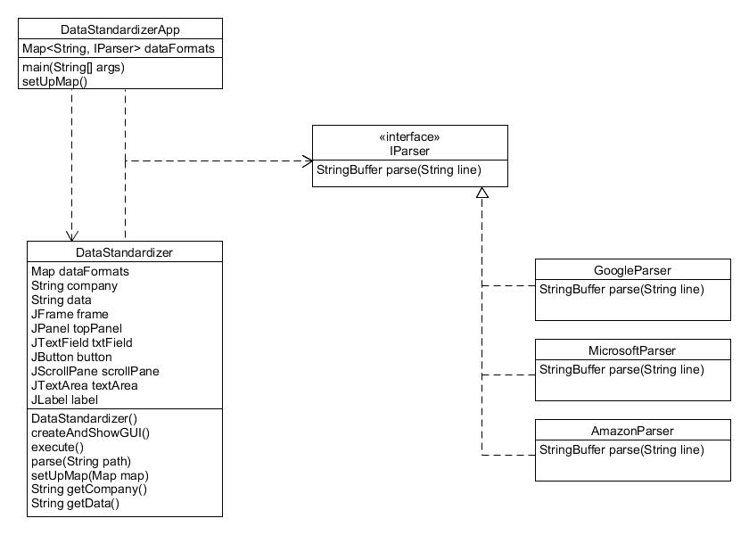

The DataStandardizerApp creates a new DataStandardizer to run the program. The app class’s Map stores the company name as the key (ex. google) and the value is the corresponding parser class to reformat the data. Once the DataStandardizer has the map set up, then the parse method just uses the first line of each file, the company name, to reformat the data. To support another company’s data, a new parser class needs to be made with the corresponding reformatting code. This class will then be added to the setUpMap() method in DataStandardizerApp.